Contents:

Introduction …………………………………………………………….page 1

The proposed method………………………………………page 3

- Multi-task Learning ………………………………………………..page 3

- Network Architecture …………………………………………….. page 3

- Training …………………………………………………………….page 4

- Testing ………………………………………………………………page 5

- Performance evaluation …………………………………………...page 6

Conclusion ………………………………………………………………….page 6

An All-In-One Convolutional Neural Network for Face Analysis
Rajeev Ranjan, Swami Sankaranarayanan, Carlos D. Castillo and Rama Chellappa

This paper presents a multi-purpose algorithm for simultaneous face detection, face alignment, pose estimation, gender recognition, smile detection, age estimation and face recognition using a single deep (CNN).

Introduction:

Face analysis is a challenging and actively researched problem with applications to face recognition, emotion analysis, biometrics security and more. Face detection and face verification have greatly improved when CNN-based methods are used, other tasks such as face alignment, head-pose estimation, gender and smile recognition are still challenging due to lack of large publicly available training data.

This set of tasks are chosen since they span a wide range of applications.

During training they propose to initialize the network with the model trained for face recognition task, because a network pre-trained on face recognition task possesses fine-grained information of a face which can be used to train other face-related tasks efficiently.

This paper makes the following contributions:
- Propose a novel CNN architecture for those tasks.
- Design a MTL framework for training,
- State-of-the-art performances on challenging unconstrained datasets.

Comparison with Hyperface

- They additionally solve for the tasks of smile detection, age estimation and face recognition.
- The MTL framework utilizes domain-based regularization by training on multiple datasets whereas HyperFace trains only on AFLW.
- Finally, they initialize the network with weights from face recognition task while HyperFace network is initialized using the weights from AlexNet.

Brief descriptions on the tasks

- The task of pose estimation is to infer orientation of a person’s head relative to the camera.
- The tasks of gender and smile classification from unconstrained images have been considered as a part of facial attribute inference.
- Age Estimation is the task of finding the real or apparent age of a person based on their face image.
- Face Verification is the task of predicting whether a pair of faces belong to the same person. This task is still a challenging problem for unconstrained faces with large variations in viewpoint and illumination (IJB-A dataset). They address this issue by regularizing the CNN parameters using the MTL framework, with only half-a-million samples (CASIA) for training.

Proposed Method

The proposed algorithm is trained in a MTL framework which builds a synergy among different face related tasks improving the performance for each of them.

1. Multi-task Learning
In the deep CNN, the lower layers of CNN learn features common to a general set of face analysis
tasks whereas upper layers are more specific to individual tasks.
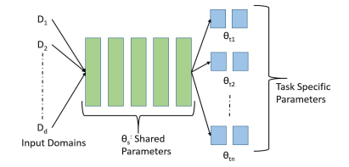

Fig. General MTL framework.

The MTL approach used in our framework can be explained by following two types of
regularization.
- Task-based Regularization:
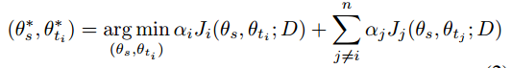
Since other tasks contribute only to the learning of shared parameters, they can be interpreted as a regularizer Ri on θs with respect to the given task ti.

- Domain-based Regularization:
we adopt the approach of training multiple CNNs with respect to task-related
datasets Di, and share the parameters among them. In this way, the shared parameter θs adapts to the complete set of domains (D1,D2,…,Dd) instead of fitting to a task-specific
domain.

2. Network Architecture

We start with the pre-trained face identification network. The network consists of
seven convolutional layers followed by three fully connected layers.

Parametric Rectifier Linear units (PReLUs) are used as the activation function.

They divide the tasks into two groups:
1) Subject - independent tasks which include face detection, keypoints localization and visibility, pose estimation and smile prediction, and visibility, pose estimation and smile prediction.
Similar to Hyperface, fuse the first, third and fifth convolutional layers for training these, as they rely more on local information available from the lower layers of the network.

2) Subject-dependent tasks which include age estimation, gender prediction and face recognition are branched out from the sixth convolutional layer of the backbone network after performing the max pooling operation.

The global features thus obtained are fed to a 3-layered fully connected network for each of these
tasks. We keep the seventh convolutional layer unshared to adapt it specifically to the face recognition task.
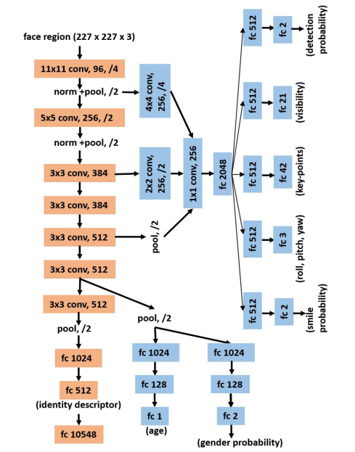

Fig. CNN Architecture for the proposed method.

3. Training
The training CNN model contains five sub-networks with parameters shared among them.
- The tasks of face detection, key-points localization and visibility, and pose estimation are trained in a single sub-network, since all of them use common dataset (AFLW) for training.
- The remaining tasks of smile detection, gender recognition, age estimation and face recognition are trained using separate sub-networks.
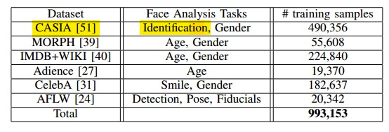
At test time, these sub-networks are fused together into a single all-in-one CNN. The datasets used are the following.
I. Face Detection, Key-points Localization and Pose Estimation:
These tasks are trained in a similar manner as HyperFace, using AFLW dataset(1000 images for testing).
For the detection task softmax loss function is used, while for the others(treated as regression problem) Euclidean loss function.

II. Gender Recognition:
It is a binary classification problem similar to face detection. A cross-entropy loss is used.

III. Smile detection:
Smile Detection: The smile attribute is trained to make the network robust to expression variations for face recognition.

IV. Age Estimation:
Treated as regression problem. And, a linear combination of the gaussian loss and Euclidean loss functions weighted by λ.
L_{A} = (1 − λ)(1/2)(y − a)² + λ (1 − exp(−(y − a)² /2σ²) ))

V. Face Recognition:
Use 10,548 subjects from CASIA dataset to train the face identification task. Using a multi-class cross-entropy loss function.

- The final overall loss L is the weighted sum of individual loss functions,
L = sum(λt * Lt) t=1,2…,8

4. Testing
They deployed a two-stage process during test time.

- First stage, use the Selective Search to generate region proposals from a test image, use Iterative Region Proposals and Landmarks-based NMS to filter out non-faces.
- For the second stage, use the obtained fiducial points to align each detected face to a canonical view using similarity transform.

5. Performance evaluation
Due to the lack of a proper evaluation protocol, the key-points visibility is not evaluated.

I. Face detection:
Evaluated on AFW, PASCAL faces, and Face Detection Dataset and Benchmark (FDDB) datasets.
The proposed method achieves state-of-the-art performance on AFW and PASCAL dataset with mean average precision (mAP) of 98.5% and 95.01% .

II. Landmarks Localization:
Evaluated on AFW and AFLW datasets, achieves a low standard deviation of 0.13.

III. Pose Estimation:
Evaluated on AFW. The proposed algorithm performs better than competing methods and is able to predict the yaw in the range of ±15◦ for more than 99% of the faces.

IV. Gender and Smile Recognition:
Evaluated on Large-scale CelebFaces Attributes (CelebA) and ChaLearn Faces of the World datasets. This method out-performs other methods by achieving on gender (99% - celebA, 93.12%- chalearn), smile(90.3% on chalearn).

V. Age estimation:
use Chalearn LAP2015 [12] apparent age estimation challenge dataset and FG-NET [15] Aging Database. The method surpasses human error of 0.34 and perform comparable to state-of-the-art methods, obtaining an error of 0.293 on Chalearn LAP2015 dataset. On FG-Net, we significantly outperform other methods, achieving an average error of 2 years.

VI. Face Identification/Verification:
Evaluate the tasks of face recognition and verification on the IARPA Janus Benchmark-A (IJB-A) dataset. Trained a Triplet Probabilistic Embedding (TPE) [41] using the training splits provided
by the dataset. With this it’s achieved a significantly faster query time (0.1s after face detection per image pair). We get a consistent improvement of 2% to 3% over the baseline network for all metrics.

VII. Runtime:
They implemented the all-in-one network on a machine with 8 CPU cores and GTX TITAN-X GPU.

CONCLUSIONS AND PROPOSED FUTURE WORKS

This work demonstrates that subject-independent tasks benefit from domain-based regularization and network initialization from face recognition task. Also, the improvement in face verification and recognition performance compared to clearly suggests that MTL helps in learning robust feature descriptors.

In future, they’d planned to extend this method for other face-related tasks and make the algorithm real time.

